NWG: Software Bootcamp M3 Agile software development (M2 in SDL6)
Notes for Mike
If a whole course from Cloud Academy/Bud can be added as it is, use its name in the ‘Course title’ in column 1, ignore the lecture titles in column 2 as I can take those from the current course and add the link to the course in column 3. Use columns as usual.
OR if you want to map individual parts of existing courses instead of whole existing courses, please map content as per the notes below:
- Course title: Insert the Course/Knowledge Check (Exam)/Lab/Resource/Activity title
- Lecture title: Insert the title of the lecture
- Mapping to existing content: Insert one or a combination of the following:
- Cloud Academy: URL/breadcrumb
- Word document that you have created and uploaded to our folders
- Other portal: URL
- Content type: Insert one of the following – Article, Lab, Knowledge Check, Resource, Video
- Timings: Insert timings for existing content. If no existing content, timings will be added by the LD
- Notes: In the notes column add any relevant comments and identify:
- If we can use the content as is or if we need to make revisions (with brief details of what needs to be revised/added/removed). You could add screen shots to this doc below the table and reference them in the notes column. If there are any gaps, i.e. do we need to author new material
- Graphics – you only need to add information in this column if you want to add a new graphic. Ones from existing courses that you’ve mapped will be included automatically.
- Consider if we need to add any topics to cover the spec (see details below the mapping table)
- Consider if topics need to be combined/split out further

Ignore the greyed-out rows in the table. They’re for the LD.

Mapping Discover/Digital
Course titles | Lecture titles (topics) | Mapping to existing content (URL) | Content Type | Timings (mins/ secs) | Graphics (Y/N) and how many | Mapping to spec topic list | Notes
Welcome and Introduction | Overview for Network Infrastructure | n/a | Article | 2 mins | N | n/a | This and the following lecture will sit at the start of the Learning Path to set the scene
 | Learning Outcomes? | n/a | Article | 2 mins | N | n/a | As above
Personal reflection | n/a | n/a | Resource | 30 to 60 mins | N | n/a | This and the following resource will sit at the end of the Learning Path.
End of Learning Path and Next Steps | n/a | n/a | Resource | 1 min | N | n/a | As above

Discover Topics [See row 1 of the spec below]
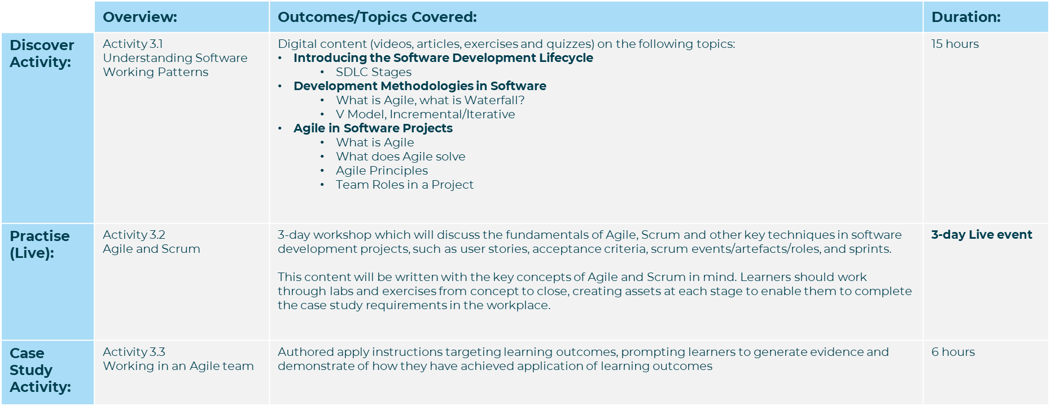

Suggested source content:
Here's an initial list of agile software development digital content we can use when you have reviewed it. Please use the mapping document to confirm what can be re-used. You will need to identify any gaps in coverage against the spec and write it. Total duration for Discover/Digital should be 15 hours:
Agile Software Development
 | Content? | Resource | Comments
Digital | Yes | https://app.qa.com/learning-paths/discover-agile-software-development-online-sdl3-rs-a12-1698-6005/  https://app.qa.com/learning-paths/scrum-master-online-learning-1-890/  https://app.qa.com/learning-paths/facilitating-purposeful-agile-meetings-910/  https://app.qa.com/learning-paths/managing-conflict-in-agile-teams-931/  https://app.qa.com/learning-paths/the-scrum-master-as-a-change-agent-950/
Live | Yes | Software L3 Module 1 (ILT) Possbility to use Mark Rogers recently created content on this subject if required.
Apply (Case Study) | Yes | Software L3 Module 1 apply activity | Need review from Ian Gates to confirm suitability

Screenshots

